Service info.

PT5664/50: Exchange of INTENSITY potentiometer.

The service manual describes how to access the potentiometers on the CRT control unit.
Please refer to attachment.

However, for exchange of the Intensity potentiometer, a more simple procedure may be used.

- Remove the potentiometer knob with shaft:
- use tweezers or pliers to squeeze the retention part of the shaft sitting in the potentiometer.
- De-solder the potentiometer using a de-soldering wick or similar.
- Replace the potentiometer.
- Fix the shaft again; beware of the marking of the cap!
Support the potentiometer when pushing the shaft in place.

3.3 Access to and Removal of the Power Supply - Unit 1
- Turn the PT 5664 upside-down
- Remove three screws "G" and lift the Power Supply unit out carefully
- To get access to the solder side, the 10 screws holding the PCB onto the plate underneath must be removed
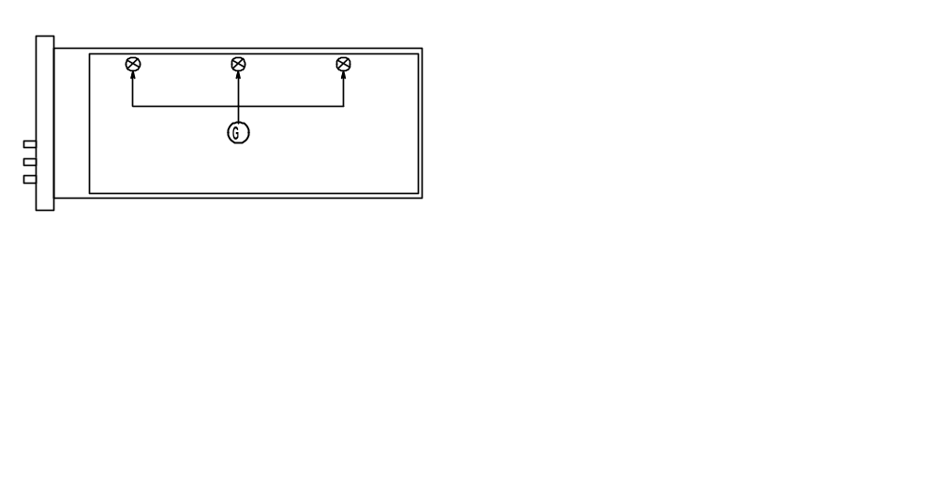
Fig. 4-5 Power Supply unit

3.4 Access to and Removal of the CRT Control Unit - Unit 2
- Remove the three knobs "H" (see fig.4-6)
- Remove the "upper" hexagonal screw which holds the PCB onto the frame of the instrument
- Remove Unit 1 as described in paragraph 3.3
- Remove the "lower" hexagonal screw which holds the PCB onto the frame of the instrument
- Pull out the unit

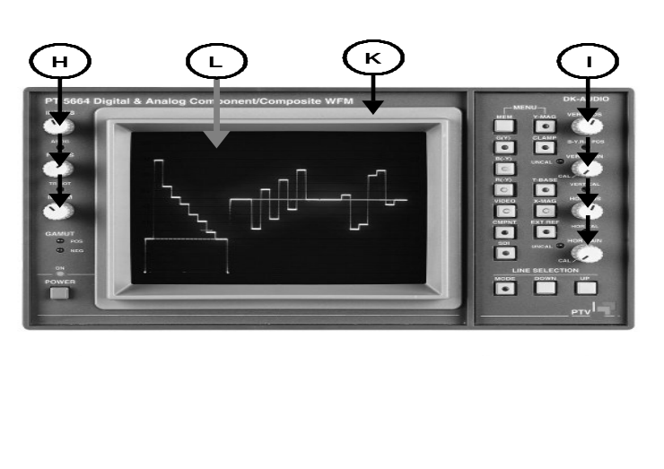
Fig. 4-6 Front of instrument.

